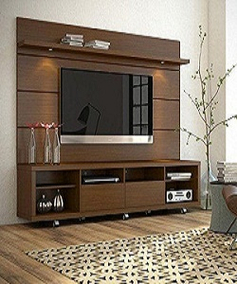

Stylish TV stand

$228.75

Availability: In stock

### Description

Stylish brown wall panel for TV with shelves. Crafted of manufactured wood with solid wood veneers in a rich woodgrain finish. Set on four caster wheels, the stand features partitioned shelves and an enclosed cabinet between two wide panels, perfect for housing your cable box, entertainment console, and other A/V essentials, while the TV panel provides a backboard for mounting flat-screen TVs. Rounding out the design, a built-in upper shelf offers even more space for storage and display.